Components (Parts) of a Client Request

🔹 What are the Components (Parts) of a Client Request?
# Source: Chatgpt (GPT-5-Mini) at [1/16/2026]
When a client (like a browser or app) sends a request to a server, it includes several parts that help the server understand what the client wants and how to process it.

✅ Main Components of an HTTP Request:
# Source: Chatgpt (GPT-5-Mini) at [1/16/2026]
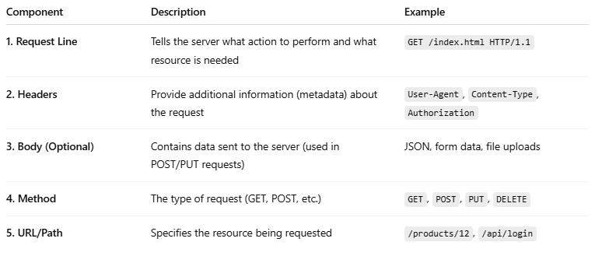
Component | Description | Example
1. Request Line | Tells the server what action to perform and what resource is needed | GET /index.html HTTP/1.1
2. Headers | Provide additional information (metadata) about the request | User-Agent, Content-Type, Authorization
3. Body (Optional) | Contains data sent to the server (used in POST/PUT requests) | JSON, form data, file uploads
4. Method | The type of request (GET, POST, etc.) | GET, POST, PUT, DELETE
5. URL/Path | Specifies the resource being requested | /products/12, /api/login

🔍 Breakdown of Each Part:

1. Request Line
# Source: Chatgpt (GPT-5-Mini) at [1/16/2026]
- Includes:
  - HTTP Method (e.g., GET, POST)
  - Resource Path (what you're asking for)
  - HTTP Version
📘 Example:
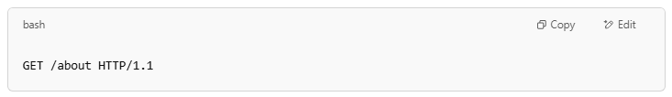
GET /about HTTP/1.1

2. Headers
# Source: Chatgpt (GPT-5-Mini) at [1/16/2026]
- Key-value pairs that describe the request.
- Examples:
  - Host: www.example.com
  - User-Agent: Mozilla/5.0
  - Content-Type: application/json
  - Authorization: Bearer token123

3. Body (only in some requests like POST, PUT)
# Source: Chatgpt (GPT-5-Mini) at [1/16/2026]
- Contains data being sent to the server (e.g., form input, JSON).
📘 Example:
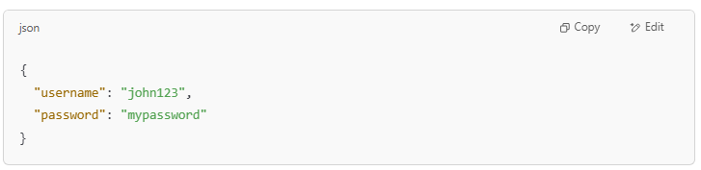
{
"username": "john123",
"password": "mypassword"
}

4. Method
# Source: Chatgpt (GPT-5-Mini) at [1/16/2026]
- Tells the server what action to take:
  - GET → Get data
  - POST → Submit data
  - PUT → Update data
  - DELETE → Remove data

5. URL/Path
# Source: Chatgpt (GPT-5-Mini) at [1/16/2026]
- The specific location of the resource on the server.
📘 Example:
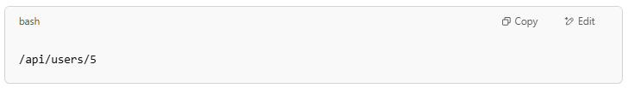
/api/users/5

🧠 Example Full HTTP Request:
# Source: Chatgpt (GPT-5-Mini) at [1/16/2026]
POST /api/login HTTP/1.1
Host: www.example.com
Content-Type: application/json
Authorization: Bearer abc123

{
"username": "user1",
"password": "pass123"
}

Let me know if you’d like to see how this works in code or a real browser request.

